DEPARTMENT OF ELECTRICAL ENGINEERING & ELECTRONICS

Project Plan for project ‘Smart Portable Respiratory Assistance and Monitoring Device for Rural Healthcare’
Author: Muhammad Hamza Taher (201723236)
Project Supervisor: Dr Munira Raja
Project Assessor: Dr Roberto Ferrero

Declaration of academic integrity

By submitting this work, I confirm that I have read and understood the University’s Academic Integrity Policy.
By submitting this work, I confirm that I have acted honestly, ethically and professionally in conduct leading to assessment for the programme of study.
By submitting this work, I confirm that the work I am submitting is my own. I have not commissioned production of the work from a third party or used artificial intelligence software in an unacceptable manner to generate the work*. I have not copied material from another person or source, nor committed plagiarism, nor fabricated, falsified or embellished data when completing the attached piece of work. I have not colluded with any other student in the preparation and/ or production of this work.
*Software applications include but are not limited to, ChatGPT, Bing Chat, DALL.E, Bard
Contents
Project Plan for project ‘Smart Portable Respiratory Assistance and Monitoring Device for Rural Healthcare’ 1
0. Project Scope 3
1. Project objectives 4
2. Project Requirements 6
3. Work packages and Methodology 8
3.1 Methodology 8
3.2 Work Packages 9
4. Skills and Resource Audit 13
4.1 Skills Audit 13
4.2 Resource Audit 14
Appendix 1. A Gantt chart 15
Appendix 2. The Risk Assessment Form 16
Appendix 3. FYP Ethics Self-Assessment. 22
Appendix 4. Block Diagram 23
Appendix 5. Initial Web Design 24
Appendix 6. References 25

List of Tables
- Project Requirements ………………………………………………………………………………………………6
- Skills Audit …………………………………………………………………………………………………………..…13
- Components List ……………………………………………………………………………….……………………14
- Resource List …………………………………………………………………………….……………………………14

Project Scope
This project focuses on the development of an affordable biomedical health monitoring device which records and transfers vital data of the patient wearing the device to a secure mobile app used by a doctor in the nearest hospital to diagnose and give advice on how to proceed with either medication or a hospital visit [1]. The market for monitoring devices is rapidly growing, yet to reach its peak, allowing this device to learn from others in the market and improve their design for rural use [2] [3].

South Asia, through the effects of colonisation, exploitation, and political struggles, has caused many areas to lack access to instant healthcare [4]. As there are no solid transportation links between these rural areas to the nearest hospital residents who are ill take longer alternative routes, such as walking or by horseback, which can worsen their condition [5] [6]. The time taken to arrive at the hospital is further affected by the busyness of the hospital and the availability of doctors at that moment in time to see patients without a set appointment [7]. By utilising this device, rural access to healthcare will be transformed as patients will have real-time online health consultation and monitoring, while doctors can have easier access to patients’ vitals to make decisions [8].

The device is portable and durable using its laser cut MDF/PLA body while having a CPAP mask and breathing tube which works with a motorised pump with 3D printed components to act as a ventilator [9] [10]. The mask has built in sensors modules (temperature, heart rate, blood oxygen, and air pressure) to measure the vitals of the patient [11]. A Raspberry Pi Pico receives the sensor data along with button input (to control the ventilator and power) [12]. The data is sent to a Raspberry Pi Zero-2 which displays the information on the LCD/OLED display while sending it wirelessly to the webpage [13].

Project Objectives
Code -> SX: WY = Semester X: Week Y

Heart Rate and Blood Oxygen:
Program a hardware module on the mask that accurately measures the Heart Rate (in BPM between 0-240BPM) and Blood Oxygen (between 70% to 100% SpO2) of the patient which display the measurements on the website and LCD, while showing real-time changes in the readings (within 5s of real-time). This is a critical feature for the project’s success as it’s a major vital measure, which must be functional by S1W5 and calibrated by S2W2.

Temperature:
Program a hardware module on the mask that accurately measures the temperature (0°C to 100°C) of the patient which display the measurements on the website and LCD, while showing real-time changes in the readings (within 5s of real-time). This is a critical feature for the project’s success as it’s a major vital measure, which must be functional by S1W6 and calibrated by S2W4.

Air Pressure:
Program a hardware module on the mask that accurately measures the respiratory pressure (70mmHg to 100mmHg PaO2) of the patient which display the measurements on the website and LCD, while showing real-time changes in the readings (within 5s of real-time). This is a critical feature for the project’s success as it’s a major vital measure, which must be functional by S1W6 and calibrated by S2W4.

Knobs:
Have functional knobs to control the ventilator, and ON/OFF switch for long term durable use which are tested with speed of change on the ventilator and circuit. Needed to help adjust the ventilator for safety using potentiometer, to be functional by S1W12 and fully tested by S2W6.

Display:
Set a readable LCD/OLED display that can be read clearly from up to 3 meters away to let medical practitioners read the vitals. Needed for accessible medical info for people and be functional by S1W5 and fully tested by S2W3.

Data transmission:
Creating a continuous secure data flow from the microcontroller to the website to display data from sensors which are used for diagnosis, with speed and delay measure using bandwidth and online speed tests for further calibration. An integral part of the project to display rapid continuous real time vital measurements on the website for healthcare practitioners as its needed to be functional by S1W8 and fully tested by S2W7.

Power:
Develop an efficient power system using a 12V lithium-ion battery to power both microcontroller and components with specified voltages using resistors which is tested using a stopwatch, a Multimeter and log calculations for charge and discharge of power with the power supply across the circuit. Necessary to provide the right amount of voltage and current to the circuit for a working device being functional by S1W8 and calibrated by S2W5.

Mask Design:
Design/manipulate a mask so it has room for the sensors to safety is without causing any injury (tested by finding and sanding down sharp edges and adding cushions). Needed for safe use by patients, and to be functional by S1W10 and fully tested by S2W6.

Pump Design:
Create an efficient ventilator pump design which can be adjusted for volume and speed using functional knobs which is measured using an air pressure monitor and balloons to find correct calibration for certain configurations. Necessary for the ventilator to adjust for patient comfortable with it being functional by S1W10 and fully tested by S2W6.

Box Design and Portability:
Designing a professional portable, durable dox design out of PLA/MDF material which can withstand being dropped by 1 metre and having no sharp edges lesser than 45 degrees while having a supportive rack for the ventilator and mask. Necessary to ensure it can survive rough climates and be portable for long distances while being functional by S1W12 and fully tested by S2W7.

Project Requirements

Category | Identifier | Description
Environmental Measurement | ENV-01 | Humidity Range:  Measure environmental humidity between 0% to 100% with a resolution of ± 1%. Tested against a calibrated sensor for accuracy.
Environmental Measurement | ENV-02 | Temperature Range:  Measure body temperature between 0°C to 100°C with a resolution of ± 1°C. Tested against a calibrated sensor for accuracy.
Medical Measurement | MED-01 | Heart rate Range:  Measure 0-240BPM with a resolution of ±1BPM. Tested against a calibrated sensor for accuracy.
Medical Measurement | MED-02 | Blood Oxygen Range:  Measures oxygen saturation between 70% to 100% SpO2 with a ±2% resolution. Tested against a calibrated sensor for accuracy.
Medical Measurement | MED-03 | Blood Oxygen response Time:  Gains a stable SpO2 reading within 5 seconds with a ±2% error margin. Tested against a calibrated sensor for accuracy.
Medical Measurement | MED-04 | Air Pressure Range:  Measures air pressure between 70mmHg to 100mmHg PaO2 with a ±2% resolution. Tested against a verified calibrated sensor for accuracy.
System Performance | SYS-01 | Sensor Sampling Rate:  Internal sensor sampling frequency ≥50Hz for rapid data capture. Verified using stopwatch and calibration.
System Performance | SYS-02 | Sensor to Display Latency:  Time delay between sensor detecting new reading to LCD display ensuring its <250ms.
System Performance | SYS-03 | Sensor to Webpage Latency:  Time delay between sensor detecting new reading to webpage display ensuring its <500ms.
System Performance | SYS-04 | Display Update Rate:  Ensure the LCD refreshes at >25fps for smooth visuals.
Connectivity and Security | SEC-01 | Webpage Reconnection:  Automatically reconnect to the website within 5ms of a disconnection, for continuous data communication.
Connectivity and Security | SEC-02 | Security and Privacy:  Implement a basic encryption to the data and a password login page for the website.
Display and Usability | DIS-01 | LCD Readability:  Ensure screen remains on and is readable from 3 meters away for accessibility of info.
Power | POW-01 | Battery Life:  Support continuous usage of >10 hours of use per full charge. Validated by repeated discharge from 100%.
Power | POW-02 | Charge Time:  Recharges to full 100% capacity (100%) within 3 hours of charging. Validated using a stopwatch.
Safety and Compliance | SAF-01 | Electrical Safety:  Ensure devices compile with university electrical safety standard, inspected by technician and supervisor.
Safety and Compliance | SAF-01 | Alarm Function:  Alarm to trigger on the website if readings exceed given limits. Tested by devices to achieve extreme reading.
Time Keeping | CLK-01 | Clock Accuracy:  Internal clock maintains synchronised within ±30 seconds to local time.
Table 1: Project Requirements

Work Packages and Methodology

3.1 Methodology
Using an engineering decomposition approach, the project is turned into two 2 designs, one across each semester [14]. This approach breaks each design into the individual sensor, module and software to allow for each to be solved and later combined to be tested as the finished device. It also used the agile development method to allow flexibility and additions in each iteration of the project [15].

By using a Gantt chart, weekly meetings, and a logbook, I can keep track of all progress throughout the project. As shown in the Gantt Chart in Appendix 1, the project is split into creating the Initial Prototype in Semester 1 and subsequently an improved Final Design in semester 2 [16].

Semester 1 is broken into:
- Initial Documents, Order, and Research (Yellow)
- Testing Components (Red)
- Designing the Initial Design (Orange)

Semester 2 is broken into:
- Evaluation and creation of the Final Design (Blue)
- Poster and Bench Inspection (Purple)
- Final Specification (Green)

3.2 Work Packages

WORK PACKAGE DESCRIPTION
WP Title: | System Requirement and Research | WP number | 1
Start Event: | Project introduction and Research Phase
Duration: | 3 weeks
Objectives:
Initial research into the system requirements, circuit design, and needed components of the device along with success criteria, methodology and lab schedule to meet deadlines
Task Description:
- Define the functional and non-functional system requirements, aims and objectives
- Create the methodology, lab schedule, and production process
Inputs:
- Project proposal and description
- Research onto existing products and their uses
- Supervisor input on limitation and goals
Interfaces/links with other tasks or WPs:
- Creates foundation for WP2 (Hardware Development) and WP2 (Software Development)
- Its output influences all other work packages which use the success criteria found
Deliverables:
- Methodology and lab schedule
- Assessment Project Plan document

WORK PACKAGE DESCRIPTION
WP Title: | Hardware Development | WP number | 2
Start Event: | Completion of WP1
Duration: | 3 weeks
Objectives:
Select components based on parameters to test individually in the prototype design with microcontroller, battery, and display integration.
Task Description:
- Design and develop the systems hardware components
- Integrate sensors, power systems, and display.
Inputs:
- Requirements and achieved products from WP1
- Sensor data sheets and specification
Interfaces/links with other tasks or WPs:
- Links and closely connected to WP3 (Software Development) for firmware compatibility
- Helps feeds into WP5 (system integration and testing)
Deliverables:
- Assemble hardware for prototype 1
- Circuit schematics and design with correct documentation

WORK PACKAGE DESCRIPTION
WP Title: | Software Development | WP number | 3
Start Event: | Hardware design start of WP2
Duration: | 2 weeks
Objectives:
Develop the firmware to connect components to the microcontrollers to enable communication been components, ready for web connection,
Task Description:
- Write embedded C/C++ code for each of the sensors for data acquisition
- Implement wireless communication for data transmission
Inputs:
- Hardware configurations from WP2
- Development tools and libraries for the microcontroller
Interfaces/links with other tasks or WPs:
- Interfaces with W2 (Hardware Development) for firmware integration
- Provides data communication framework for WP4 and WP5
Deliverables:
- Embedded C/C++ firmware code
- Software testing documentation

WORK PACKAGE DESCRIPTION
WP Title: | Web Development | WP number | 4
Start Event: | Completion of WP3
Duration: | 2 weeks
Objectives:
Design the companion website to display the health data from the sensors and connect it to the microcontroller.
Task Description:
- Creates an application to receive and display transmitted data
- Development of a user-friendly interface
Inputs:
- Data transmission firmware from WP3
- UX design guidelines for a clean easy to use interface
Interfaces/links with other tasks or WPs:
- Works alongside WP3 for data communication
- Connects to WP5 and WP6 for system testing and validation
Deliverables:
- Functional web prototype that communicates with the device

WORK PACKAGE DESCRIPTION
WP Title: | System Integration and Testing | WP number | 5
Start Event: | Completion of WP2, WP3, and WP4
Duration: | 2 weeks
Objectives:
Integrate all previous subsystems into an operational prototype (able to sense health data and display on LCD and website) to test and identify weaknesses and ways to optimise the design.
Task Description:
- Integrate all the sub-systems (hardware, software, and firmware) to one model
- Evaluate the compete initial porotype’s system performance and stability
Inputs:
- Working prototypes from previous Work Packages
- Test equipment and software tools
Interfaces/links with other tasks or WPs:
- Directly dependant of WP2, WP3, and WP4
- Creates the foundation for WP6 (testing and validation
Deliverables:
- Integrated evaluation and improvement report
- Create the hardware-software interface documentation

WORK PACKAGE DESCRIPTION
WP Title: | Testing and Validation | WP number | 6
Start Event: | The completion of the initial prototype, WP5
Duration: | 3 weeks
Objectives:
Compare prototype readings to accurate references to calibrate sensors and optimising overall device design such as website, circuit schematics, etc.
Task Description:
- Validate and test the systems accuracy, safety and reliability
- Verify and understand the correct data transmission and alarm
Inputs:
- Integrated systems from WP5
- Calibration instruments and reference data
Interfaces/links with other tasks or WPs:
- System systems from WP5 for validation
- Prepares changes for WP5 in creating the final design
Deliverables:
- Validation and calibration reports
- Transmission and data accuracy for changes
- Optimisation of circuit diagram for the final design

WORK PACKAGE DESCRIPTION
WP Title: | Creation of the Final Design | WP number | 7
Start Event: | The completion of testing and validation of the initial prototype, WP6
Duration: | 4 weeks
Objectives:
Creating the final design with optimised data from the WP6 to have an efficient device that can accurately display health data.
Task Description:
- Find ways to optimise the initial protype for the final design
- Creating the final design using optimised circuit design
Inputs:
- Test data from WP5
- Validation reports from WP6 for calibration and repair
Interfaces/links with other tasks or WPs:
- Links with WP2, WP3, and WP4 for all the created design
- Needed for the final documentation and report of the project
Deliverables:
- The final design which has been optimised for bench inspection
- Validated and correct test data
- Information for the final documentation

WORK PACKAGE DESCRIPTION
WP Title: | Documentation | WP number | 8
Start Event: | Completion of the final design
Duration: | 3 weeks
Objectives:
The collection of all circuit diagram, code and test results to produce the final specification, information for bench inspection, and academic poster.
Task Description:
- Combination and collection of all research, test results, diagram and code of the project
- Creation of the final specification report, bench inspection presentation, and poster
Inputs:
- Output of all the previous work packages
- Project logs and validation reports
Interfaces/links with other tasks or WPs:
- Combines all previous work packages (WP1-7)
- Provides the final material for submission and marking
Deliverables:
- Collection of all project documents
- Final report, presentation, and academic poster

Skills and Resource Audit

4.1 Skills Audit

Skills | Level | Training Needs
Circuit design with soldering and PCB development | Proficient | - Learn to create and design PCBs for commercial use  - Improving current soldering skills  - Watch YouTube videos on how to efficiently design circuits
Embedded systems Programming (C for Raspberry Pi) | Proficient | - Practice with real time labs  - YouTube videos and tutorials on using raspberry pi  - Coding websites on C and C++
Sensor integration design | Proficient | - Check specification of sensors for compatibility  - Recap experience from last 2 projects which used sensors
Battery and power system design | Intermediate | - YouTube videos and tutorials on using rechargeable batteries  - Practice in labs  - Voltage divider calculations
Calibration and accuracy testing | Proficient | - Practice in labs using sensors  - Comparing accuracy of sensors to real-life device
Experiment design | Proficient | - Understand objectives and aims of the experiment  - Try different types of testing methods
Analysis of biomedical data | Intermediate | - Research medical data levels and their meanings  - Websites for data analysis
Data security and privacy | Intermediate | - Read university guidelines  - Utilising teams for data protection
Project management and Documentation | Proficient | - Regular meetings with my supervisor  - Track progress via a Gantt chart and milestones
Literature review and scientific research | Proficient | - Research into biomedical testing  - Practice writing literature review and improving via feedback
CAD design | Proficient | - Practice creating intricate designs on CAD software  - Watch tutorials on YouTube
Website development | Proficient | - Practice creating intricate designs on web dev sites  - Watch tutorials on YouTube to find out ways to create a website
Table 2: Skills Audit

4.2 Resource Audit

Components List:
Components | Component Type | Why
Raspberry Pi’s | Microcontroller | Dataflow from sensor to website
Heart Rate & Blood Oxygen Module | Module | Measure heart rate and blood oxygen
Temperature Module | Module | Measure temperature
Air Pressure Module | Module | Measure air pressure
Motor | Active | Ventilator pump
Lithium Battery | Active | Battery system
LCD or OLED | Active | Main device display
Potentiometer | Passive | Circuit design and pump adjustments
CPAP Mask and Tube | Support | Ventilator
Safety glasses | Support | General lab safety
Storage box | Support | Component and device storage
Inductors | Passive | Circuit design
Capacitors | Passive | Circuit design
Resistors | Passive | Circuit design
Power bank | Support | Battery system
PLA components (3D printed) | Support | Motor pump
Air pump | Support | Motor pump
Acrylic and wood panels | Support | Motor pump and the box design
Table 3: Components Table

Resources List:
Hardware Resources | Availability | Alternatives
Laser Cutter | EEE lab and Makerspace | Hand cutting materials
3D printer | EEE lab and Makerspace | Laser Cutter
Vinyl Machine | Makerspace | Printing and Drawing
Hand tools | EEE lab | None
Soldering Iron | EEE lab | None
Multimeter | EEE lab | None
Power Supply | EEE lab | None
Oscilloscope | EEE lab | None
Crocodile clips and wires | EEE lab | None
PCB machine | EEE lab | Soldering Components
Devices (MacBook & iPad) | On my person | University Desktops
Autodesk | Online | Other 3D modelling software
VS Code | Online | Other Software IDE
Multisim | Online | Other circuit designer
Web Development site | Online | Other web development site
MATLAB | Online | Other Software IDE
Microsoft Office Package | Online | Google Package
Table 4: Resource Table

Appendix 1. A Gantt chart

Semester 1:
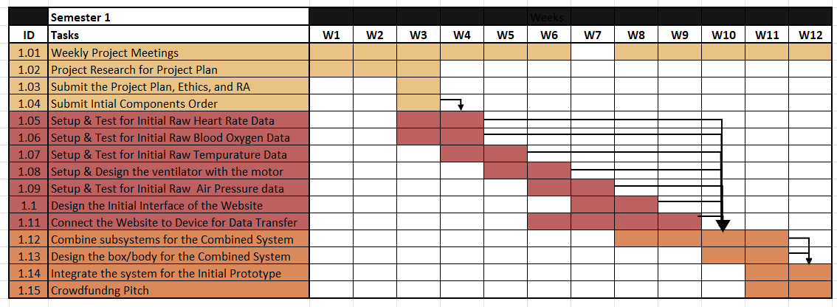

Semester 2:
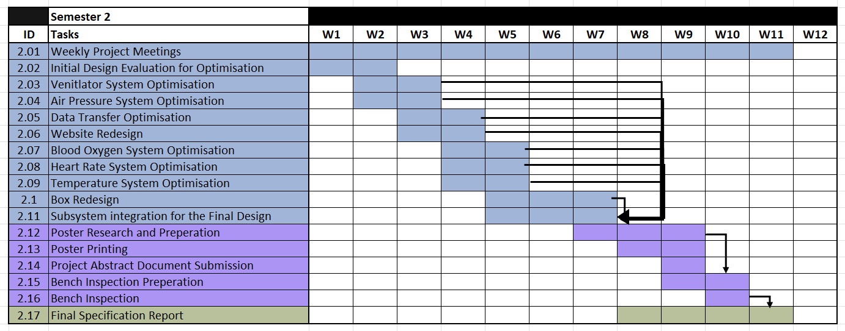

Whole Year:
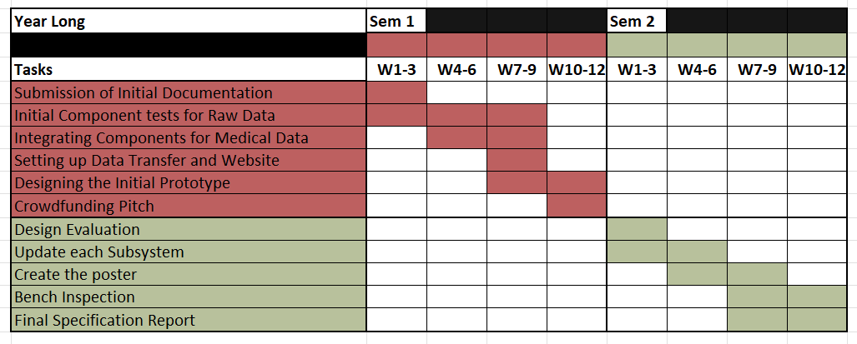

Appendix 2. The Risk Assessment Form
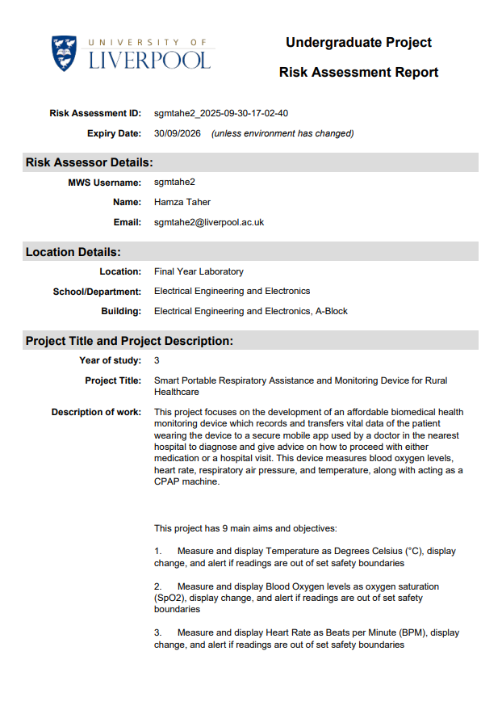

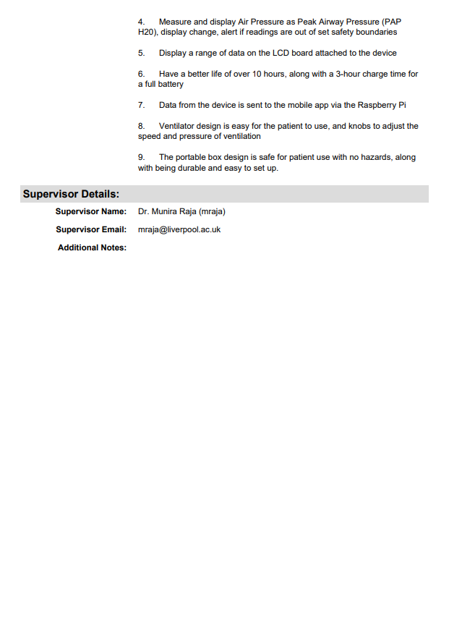

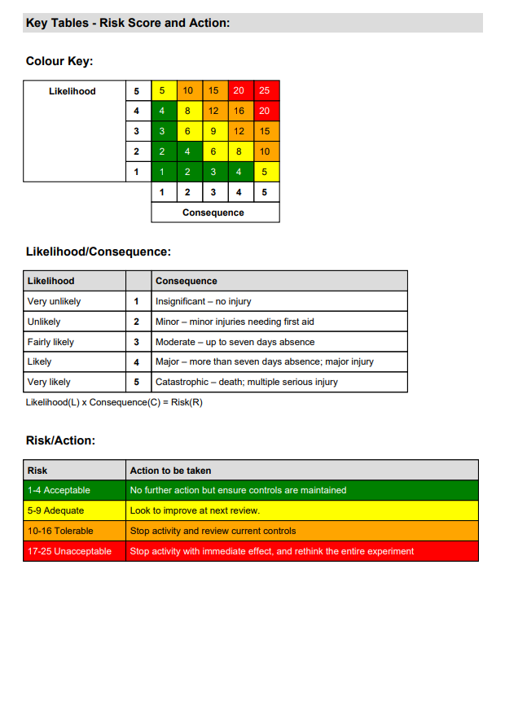

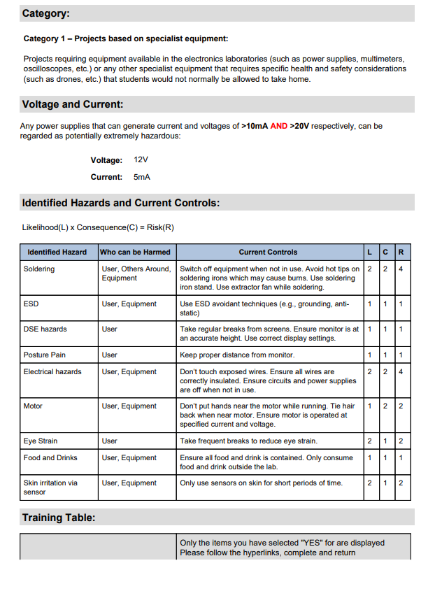

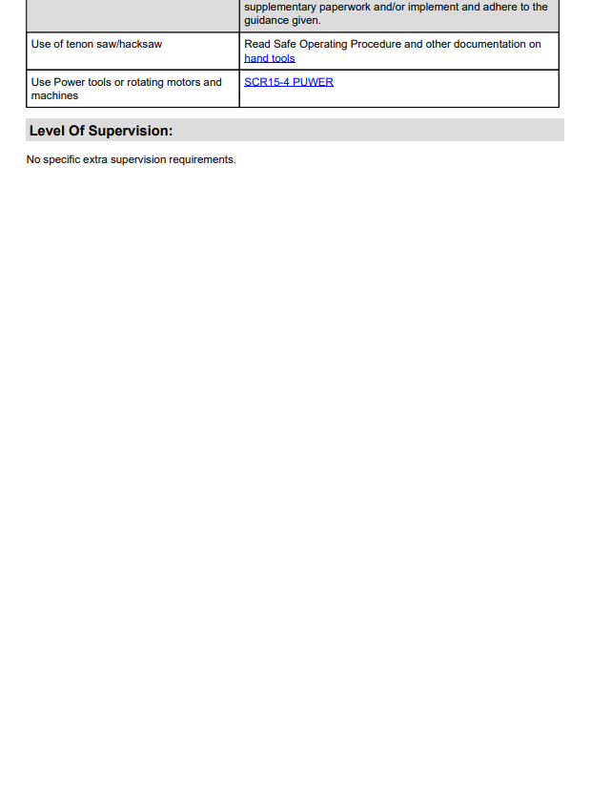



Appendix 3. FYP Ethics Self-Assessment.
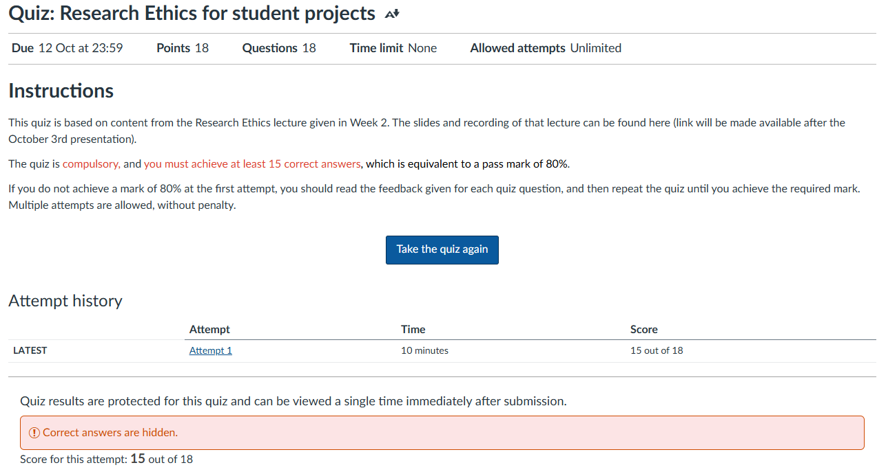

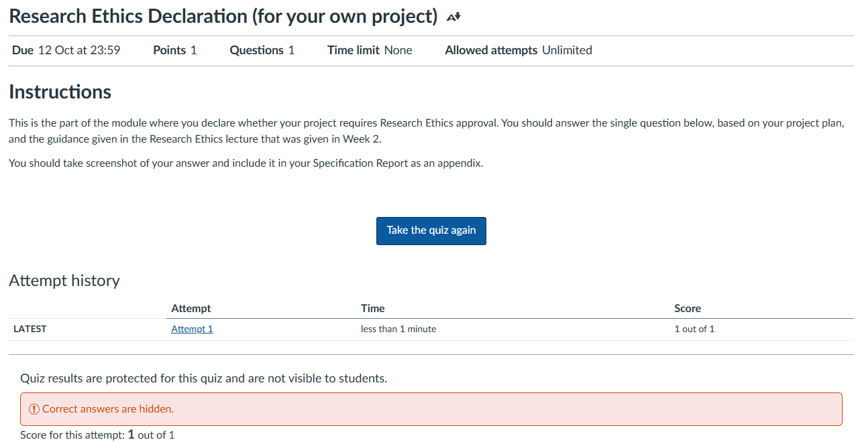

Appendix 4. Block Diagram

As seem below, the two central components of the device are the microcontrollers (colour coded green) which are both raspberry pi for compatibility, these are MC1, a Pi Pico, and MC2 which is a Pi Zero 2.

MC1 gets its inputs from the buttons (pink), B1 and B2 control the motor speed for the ventilator while B3 is the on and off switch. MC1 controls the motor (purple) using the changes in input from the buttons. It also controls and takes data from the 3 sensors (orange), S1, S2, and S3 which measure the Heart Rate and Blood Oxygen, Temperature, and Air Pressure. Finally, its connected MC2 where it communicates all the data.

This was designed so MC1 deals with the main bulk of the processing of data and changing inputs to motor movements, so it can send the data to display to MC2 which is connected to the LCD/OLED display (yellow), and wireless transmits the data to the webpage (maroon).

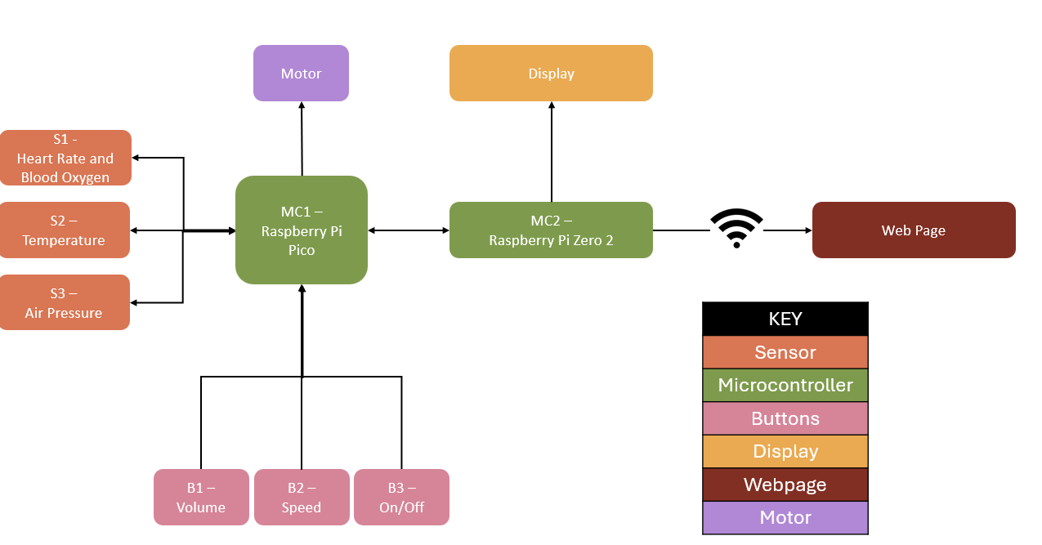

Appendix 5. Initial Web Design
The webpage has a simple design which shows the doctors name, settings and account details tab in the header.

The data is then split into two boxes; the first box is the patient’s information which includes:
- Name
- ID
- Location
- Time

The bottom box holds the sensor reading which includes:
- Heart Rate
- Average Heart Rate
- Peak Heart Rate
- Lowest Heart Rate
- Temperature
- Blood Oxygen
- Air Pressure
- Humidity

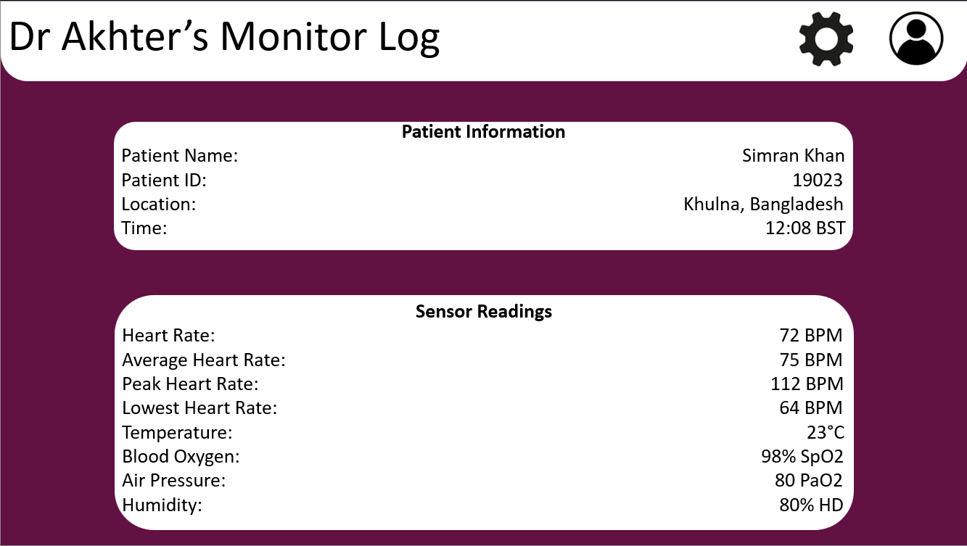

Appendix 6. References

- R. Bloss, “Wearable sensors bring new benefits to continuous medical monitoring, real time physical activity assessment, baby monitoring and industrial applications,” Sensor Review, vol. 35, no. 2, pp. 141–145, Mar. 2015, doi: https://doi.org/10.1108/sr-10-2014-722.

- K. Mahalakshmi, V. R. Palanivelu, and Dharmalingam Kirubakaran, “Global Market Trends in Biomedical Sensors: Materials, Device Engineering, and Healthcare Applications,” Deleted Journal, May 2025, doi: https://doi.org/10.1007/s44174-025-00362-w.

- N. Kasoju et al., “Digital health: trends, opportunities and challenges in medical devices, pharma and bio-technology,” CSIT, vol. 11, no. 1, pp. 11–30, Apr. 2023, doi: https://doi.org/10.1007/s40012-023-00380-3.

- “Research Portal,” Miami.edu, 2025. https://scholarship.miami.edu/esploro/outputs/991032631931202976 (accessed Oct. 06, 2025).

- “Lifelines to rural India: The evolving role of emergency medical services - Healthcare Radius,” Healthcare Radius, Jan. 23, 2025. https://www.healthcareradius.in/features/education/lifelines-to-rural-india-the-evolving-role-of-emergency-medical-services

- J. Player, “Healthcare Access in Rural Communities in India,” Ballard Brief, 2019. https://ballardbrief.byu.edu/issue-briefs/healthcare-access-in-rural-communities-in-india

- “India Covid: Hospitals overwhelmed as deaths pass 200,000,” BBC News, Apr. 29, 2021. Available: https://www.bbc.co.uk/news/world-asia-56919924

- H. S. Kang and M. Exworthy, “Wearing the Future—Wearables to Empower Users to Take Greater Responsibility for Their Health and Care: Scoping Review,” JMIR mHealth and uHealth, vol. 10, no. 7, Jul. 2022, doi: https://doi.org/10.2196/35684.

- “Library Guides: KnowHow Digital: Makerspace,” Liverpool.ac.uk, 2025. https://libguides.liverpool.ac.uk/knowhow_digital/makerspace (accessed Oct. 06, 2025).

- “Building opening times | Department of Electrical Engineering and Electronics | University of Liverpool,” Liverpool.ac.uk, 2025. https://www.liverpool.ac.uk/electrical-engineering-and-electronics/about/opening-times/ (accessed Oct. 06, 2025).

- van Noort, F. L. Becking-Verhaar, Wilmieke Bahlman-van Ooijen, M. Pel, Harry van Goor, and Getty Huisman-de Waal, “Three Years of Continuous Vital Signs Monitoring on the General Surgical Ward: Is It Sustainable? A Qualitative Study,” Journal of Clinical Medicine, vol. 13, no. 2, pp. 439–439, Jan. 2024, doi: https://doi.org/10.3390/jcm13020439.

- “Raspberry Pi Pico,” The Pi Hut, 2022. https://thepihut.com/products/raspberry-pi-pico?srsltid=AfmBOopZAoOXyodEYWeIjK_Ip-93sJLPWxYtOGIPfFAhp0T3pGiUPEAR (accessed Oct. 06, 2025).

- “Raspberry Pi Zero 2,” The Pi Hut. https://thepihut.com/products/raspberry-pi-zero-2

- Nima Bonyadi, Riccardo Talami, and B. Lee, “Breaking-down Building Design Problems with Decomposition Approaches: A Review,” Energy and Built Environment, May 2025, doi: https://doi.org/10.1016/j.enbenv.2025.05.005.

- A. Omonije, “Agile Methodology: A Comprehensive Impact on Modern Business Operations,” ResearchGate, Feb. 06, 2024. https://www.researchgate.net/publication/377979833_Agile_Methodology_A_Comprehensive_Impact_on_Modern_Business_Operations

- J. Geraldi, “Gantt Charts revisited: a Critical Analysis of Its Roots and Implications to the Management of Projects Today,” ResearchGate, 2012. https://www.researchgate.net/publication/263571905_Gantt_charts_revisited_A_critical_analysis_of_its_roots_and_implications_to_the_management_of_projects_today

